Summary
Radiocommunication Study Groups | 
 | PT46(09)025
Received: 3 August 2009 | Document 1A/157-E
Received: 3 August 2009 | 5 August 2009
Received: 3 August 2009 | English only
Germany (Federal Republic of)
Compatibility between HF aeronautical Mobile radio
and PLT In-house devices

With the growing numbers of users of PLT in-house devices the problem of the compatibility of PLT with HF radio devices increases. The following compatibility study investigates this problem with regard to the protection of HF aeronautical mobile radio (airborne receivers). The results show that mitigation techniques such as power management and notching can reduce the interference potential of PLT devices significantly and should therefore be considered in the relevant CISPR PLT standard under development.
It is proposed:
• to incorporate the study into the draft new report on “impact of power line telecommunication systems operating in the LF, MF, HF and VHF bands below 80 MHz”; and
• to bring the study to the attention of CISPR with the request to take it into account in its ongoing standardisation activities on PLT devices.

Compatibility analysis regarding protection requirements of HF aeronautical mobile radio in relation to PLT in-house devices

TABLE OF CONTENTS
Page

1 Introduction 3
2 Description of the PLT features 3
3 Compatibility model/geometrical computation 4
4 Evaluation threshold for the aeronautical radio 6
5 Results of the analysis 7
6 Other determinants 9
7 Requirements toward PLT devices for protecting the HF aeronautical mobile service 9

1 Introduction
For broadband communications within LV AC mains grids and in-house installations, modern PLT systems use the frequency range 1 705 MHz to 30 MHz.
Since such networks and installations were not constructed to ever carry wanted signals at frequencies much higher than the power frequency (i.e. 50 or 60 Hz), the level of radiated RF disturbances from such installations will significantly increase with utilisation of PLT in the field. There is no doubt that such an increase of the radio noise may result in a much higher probability of interference with radio reception in general, in locations well populated with operational PLT appliances.
This compatibility analysis focuses on the protection of airborne receivers in the aeronautical mobile service.
The calculations in this document are intended to show the extent to which PLT applications may interfere with the aeronautical mobile receiver and which possibilities there are to avoid or at least mitigate this interference.

2 Description of the PLT features
According to the functional standards, PLT devices for in-house communications operate with a maximum power spectral density (PSD) of -55 dBm/Hz or -73 dBm/Hz, respectively. Typical utilisation of frequencies in the cable presently covers the range from 1,705 MHz to 30 MHz. All commercially available systems operate with multi-carrier transmission and use OFDM (Orthogonal Frequency Division Multiplex) in combination with CSMA/CA (Carrier Sense Multiple Access/Collision Avoidance) modulation schemes.
The CISPR is about to cover and consider these functional system requirements by means of an adequate EMC standard, the second Committee Draft (CD) of which will be issued soon for the National Enquiry.
Using the information found in this CD and taking into account statistically proven HF properties of typical AC mains in-house installations in Europe one is able to estimate the level of radiated RF disturbances which emanate from buildings where PLT communication is active. For consideration of the impact of these disturbances on airborne receivers, a point source was developed using finite-element modelling. The resulting radiation characteristics of this source are shown in figure 2-1 (blue curves).
These radiation characteristics represent the normal case scenario for operation of PLT devices. The building simulated may accommodate two or more communicating PLT devices and may also cover more than one separate flat. For reasons of comparison, Figure 2-1 also contains the limits found in ECC Recommendation (05)04 which can be regarded as reference measure for a tolerable AC mains installation quality and radiation from buildings caused by wire-bound broadband communications in general.
The dotted blue curve represents the RF disturbance field strength at 10 m distance slant from the cable carrying PLT communications or, for purposes of this analysis, from the building, in z-direction. Without any mitigation measures a significant RF disturbance field strength will be observed at all frequencies utilized in the cables for PLT. The curve represents the RF disturbance field strength caused by operation of type 1 PLT devices which use a PSD of -55 dBm/Hz. For this type of PLT devices the upcoming CD specifies, in its normative Annex H, some functional requirements which ensure that type 1 PLT devices shall be equipped with mitigation features such as power management and notching. EMC testing this way demands performance checks for these features at product level.
The fortunate effects of these mitigation features in practise are that, under normal operation conditions, power management will reduce the PSD level by 18 dB and results in a respective reduction of the RF disturbance field strength also by 18 dB, are shown in figure 2-1 (blue curves).
A further reduction of the PSD level by another 30 dB can be achieved by several notching techniques, but is usually restricted to certain “sensitive” frequencies or frequency bands used for terrestrial radio communications e.g. broadcasting. The effect of notching plus power management is shown in the range of 6 MHz. For “sensitive” frequencies the resulting RF disturbance field strength can be reduced by some 48 dB. While the PLT industry already accepted general application of power management at product level, negotiations to notching just led to consideration of Amateur, CB and broadcast radio frequency bands, in the present CD.
As the compatibility analysis for airborne receivers shows, it is necessary to request extension of the notching concept also to frequencies and frequency bands utilised for aeronautical mobile radio. For these services, permanent notching should be implemented.
figure 2-1
Non-access PLT appliances, True electric component of radiated RF disturbances from
AC mains installations in a building carrying PLT (10 m distance from the outer wall or
roof of the building), Effect of power management and notching (at around 6 MHz)
(Situation in Europe where the ECC Rec. (05)04 applies, End-to-end loss
of the PLT communications link = 20 dB)
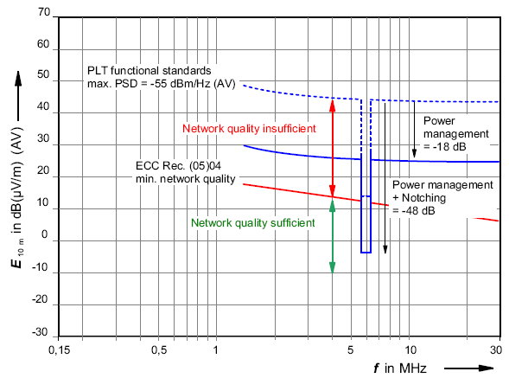

3 Compatibility model/geometrical computation
To be able to assess possible interference to airborne receivers due to summation effects from PLC sources the following compatibility model is used:
The receiver of the aircraft sees an increase in the apparent noise floor. The geometry of the problem is derived from figure 3-1.
figure 3-1
Model of the Working Group SE 35 of the ECC

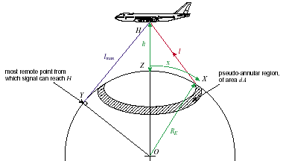

For an interference which hits the receiver directly (free space propagation)
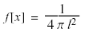
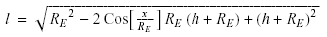
where the values of $x$ and $l$ are physically constrained not to exceed
$x_{\text{max}}=R_{E}\text{ArcCos}[R_{E}/(R_{E}+h)]$ and $l_{\text{max}}=\sqrt{h(h+2R_{E})}$ respectively
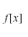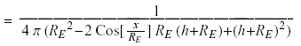
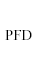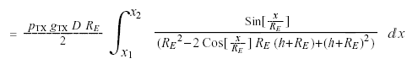
and, for the normalized form
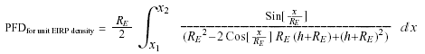
This model considers the summation effects of a specific interferer surface in relation to the interferer density (interferer per square kilometre). The corresponding interfering field strength is derived from the power flux density which may then be compared with various evaluation thresholds. The calculations were carried out using the arithmetic program Mathcad.

4 Evaluation threshold for the aeronautical radio
As evaluation thresholds for interference:
• the maximum permissible interfering field strength for the airborne receiver measured in the laboratory; and
• the noise floor measured during measuring flights;
are used (shown in figure 4-1).
The measuring flights were carried out within the scope of a working group of the BNetzA in cooperation with the NARFA (National Allied Radio Frequency Agency), the air force shipyard Landsberg and the association of German cable net operator (ANGA). Three measuring flights took place at various altitudes and the respective noise floor was measured at the frequencies 5 MHz, 14 MHz and 30 MHz. These measuring values constitute, beside the maximum permissible interferer field strength (black curve in Figure 4-1), a second evaluation threshold (magenta curve in Figure 4-1). As a third threshold on Figure 4-1 (red curve) an around 9.5 dB decreased curve is illustrated, in that a noise similar interference signal generates a total noise which would increase the measured noise floor by not more than 0.5 dB.
An increase of the noise floor by 0.5 dB is considered just still admissible to a radio service relevant for safety such as aeronautical mobile radio.
figure 4-1
Evaluation threshold regarding the compatibility between PLT and aeronautical radio
1. evaluation threshold
2. evaluation threshold
3. evaluation threshold

5 Results of the analysis
The field strengths generated by PLT application in relation to the three evaluation thresholds were examined. The following tables illustrate by how many dB the PLT interfering signal needs to be decreased to achieve compatibility in relation to the relevant evaluation criterion. The cases involving power management and notching as well as the case involving a combination of these two mitigation measure are listed.
The presented calculations are based on an interferer density of 250 interferers/km², an aircraft altitude of 1 km and a radius of the interfering area of 10 km. For the radiation characteristics of these interferers see figure 2-1. Tables 5-1, 5-2 and 5-3 specifying for different criteria (receiver sensitivity, noise increase by 0.5 dB, noise increase by 3 dB) by how many dB the interfering field surface radiated from all PLT point sources needs to be decreased (for the cases outlined above), to ensure a compatibility at the airborne receiver. A compatibility is even not given when using power management and notching. Table 5-4 sets out the relevant correction values for different interferer densities.
table 5-1
250 interferers/km², interferer field surface radius 10 km, flight altitude 1 km
Receiver sensitivity | 5 MHz | 10 MHz | 15 MHz | 20 MHz | 25 MHz | 30 MHz
PLT (-55 dBm/Hz) | -65 dB | -59 dB | -55 dB | -52 dB | -50 dB | -49 dB
PLT (power management) | -47 dB | -41 dB | -37 dB | -34 dB | -32 dB | -31 dB
PLT (notch) | -35 dB | -29 dB | -25 dB | -22 dB | -20 dB | -19 dB
PLT (power management + notch) | -17 dB | -11 dB | -7 dB | -4 dB | -2 dB | -1 dB

For maximum increase by 0.5 dB of the noise compared with the noise caused by the PLT interference signals, a power management and notching of the relevant frequencies of all PLT devices ensures a compatibility only above 20 MHz (green highlighted fields in the bottom line of the table 5-2). Below 20 MHz the calculated values are higher with a maximum of 3.5 dB.
table 5-2
250 interferers/km², interferer field surface radius 10 km, flight altitude 1 km
Noise increase by 0.5 dB | 5 MHz | 10 MHz | 15 MHz | 20 MHz | 25 MHz | 30 MHz
PLT (-55 dBm/Hz) | -50.5 dB | -51.5 dB | -51.5 dB | -49 dB | -46.5 dB | -45.5 dB
PLT (power management) | -32.5 dB | -33.5 dB | -33.5 dB | -31 dB | -28.5 dB | -27.5 dB
PLT (notch) | -20.5 dB | -21.5 dB | -21.5 dB | -19 dB | -16.5 dB | -15.5 dB
PLT (power management + notch) | -2.5 dB | -3.5 dB | -3.5 dB | -1 dB | 1.5 dB | 2.5 dB

In case of the 3rd evaluation threshold (noise increasing max. 3 dB) only a power management in combination with a notching across the relevant frequency range would be sufficient (green highlighted fields of the Table 5-3). However, this evaluation threshold should be deemed unrealistic, because of a doubling of the noise power, so the requirements of the safety-relevant radio services are not fulfilled.
table 5-3
250 interferers/km², interferer field surface radius 10 km, flight altitude 1 km
Noise increase by 3 dB | 5 MHz | 10 MHz | 15 MHz | 20 MHz | 25 MHz | 30 MHz
PLT (-55 dBm/Hz) | -41 dB | -42 dB | -42 dB | -39,5 dB | -37 dB | -36 dB
PLT (power management) | -23 dB | -24 dB | -24 dB | -21.5 dB | -19 dB | -18 dB
PLT (notch) | -11 dB | -12 dB | -12 dB | -9,5 dB | -7 dB | -6,5 dB
PLT (power management + notch) | 7 dB | 6 dB | 6 dB | 8.5 dB | 11 dB | 12 dB

For other interferer densities than 250 interferer/km² the following correction values can be used.

table 5-4
Disturber density correction
Interferer density (interferer/km²) | Correction value
50 | 7 dB
100 | 4 dB
150 | 2 dB
200 | 1 dB
250 | 0 dB
300 | -1 dB

6 Other determinants
In the above examination the interferer density was used as the most relevant compatibility parameter. Investigations with other parameters like flight altitude, the radius of the considered interferer surface or so-called “Hot Spots” proved a negligible influence on the calculations.

7 Requirements toward PLT devices for protecting the HF aeronautical mobile service
Adequate protection of aeronautical mobile airborne receivers from interference is indisputable. The question is up to which extent and by which means this can be guaranteed without compromising the evolving PLT technology.
The CISPR already provided the answer: at "sensitive" radio frequencies, mitigation measures such as notching can be used in order to reduce the PSD of the wanted PLT signal either permanently or, in adaptation to the local conditions of radio reception and the type of radio service, dynamically. A precondition for effectiveness of such measures during operation of PLT devices in the field is, however, that notching is a feature of every PLT device and not only covers the frequency bands for the amateur radio or broadcasting services, but also those dedicated to the HF aeronautical mobile service.
Due to the safety relevance of the aeronautical mobile service, a permanent reduction of the PSD of PLT devices (i.e. permanent notching) shall also be possible and shall hence be extended to the following frequency ranges:
TabLe 7-1
Frequencies of the aeronautical mobile radio
Frequency range in MHz
2.850 | – | 3.155
3.400 | – | 3.500
3.800 | – | 3.950
4.650 | – | 4.850
5.450 | – | 5.730
6.525 | – | 6.765
8.815 | – | 9.040
10.005 | – | 10.100
11.175 | – | 11.400
13.200 | – | 13.360
15.010 | – | 15.100
17.900 | – | 18.030
21.924 | – | 22.000
23.200 | – | 23.350

Since ITU-R holds an I membership in the CISPR, the upcoming National Enquiry for the Committee Draft of CISPR SC I on EMC for PLT devices should be used in order to request, in a formal way through the liaison officer of ITU-R, incorporation of the above table in the proposed Annex H, with clear reference to permanent PSD reduction (or notching).

______________

